Project SDD
Project Topic: Spam Text Detector

Name: Muhammad Sarfraz

Roll No: S23BINFT1M01129

Submitted to: Dr. Rana Nazeer Ahmad



The Islamia University of Bahawalpur

1. INTRODUCTION

1.1 Purpose
The purpose of this Software Design Document is to provide a complete and structured description of the internal design of the Spam Text Detector system. It explains how the system will be implemented, how different modules interact with each other, and how data flows through the system to produce the final output.
This document is intended for:
- Developers (for implementation guidance)
- Evaluators (for understanding system design)
- Future maintainers (for system upgrades)
The system is designed using Python and Tkinter with a rule-based NLP approach, avoiding complex machine learning models. The goal is to ensure simplicity, clarity, and ease of execution on low-resource systems.

1.2 Scope
The scope of this system includes the development of a standalone desktop application that performs spam detection using text analysis techniques.

Included in Scope
- Desktop GUI-based application
- Real-time message classification
- Rule-based spam detection system
- Keyword-based scoring mechanism
- Text preprocessing pipeline
- Offline execution

Excluded from Scope
- Machine learning models (e.g., SVM, Naive Bayes)
- Cloud-based processing
- Database storage system
- Email server integration
- Mobile application version
The system is strictly limited to rule-based NLP processing for educational and lightweight usage.

1.3 Design Goals
The system is designed with the following goals:

1. Simplicity
The system should be easy to understand and implement without advanced AI knowledge.

2. Efficiency
It should process text quickly without delays.

3. Lightweight Execution
The system should run smoothly even on low-end machines.

4. Maintainability
Code should be modular so that new features (like ML models) can be added later.

5. Usability
The GUI should be simple and user-friendly for non-technical users.

1.4 System Overview Diagram :

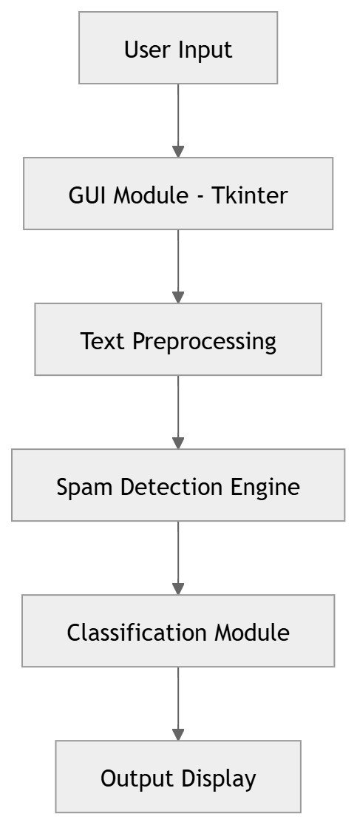

The system starts from user input through a GUI. The text is then preprocessed by removing punctuation, converting to lowercase, and tokenizing words. The processed text is passed to the spam detection engine, where keyword matching and scoring are applied. Finally, the classification module determines whether the message is Spam or Not Spam.

2. SYSTEM ARCHITECTURE
The system follows a layered architecture model. Each layer performs a specific role, ensuring modularity and maintainability.
2.1 Layered Architecture Diagram
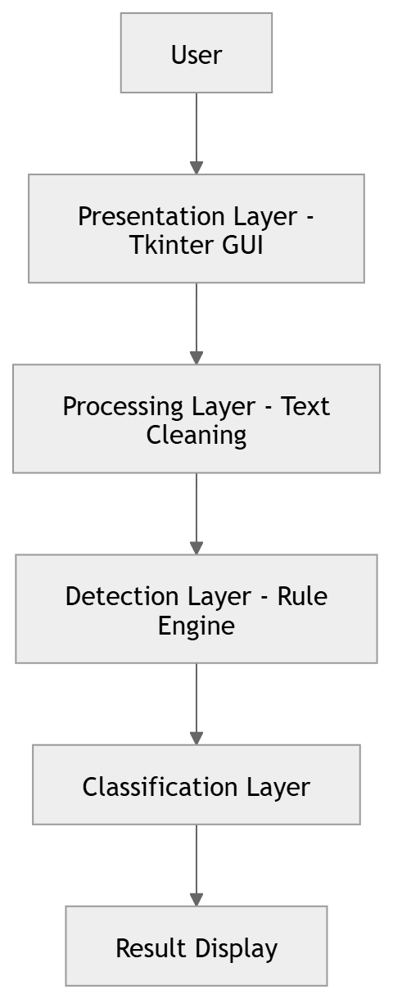

Presentation Layer
This layer handles all user interactions. It includes input fields, buttons, and result display using Tkinter GUI.

Processing Layer
This layer preprocesses the input text by converting it into lowercase, removing special characters, and tokenizing words.

Detection Layer
This is the core logic where spam keywords are matched, regex patterns are detected, and a spam score is calculated.

Classification Layer
This layer compares the final score with a threshold and determines whether the message is Spam or Not Spam.

Use case Design

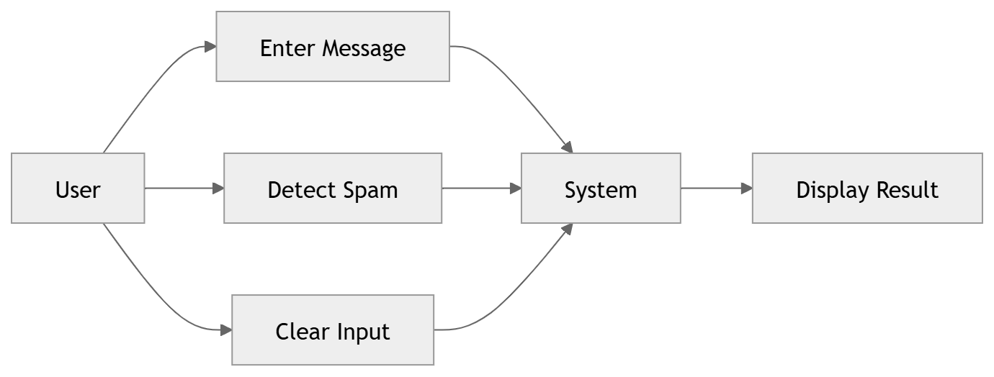

The user interacts with the system through three main actions: entering a message, detecting spam, and clearing input. The system processes the input and returns a result showing whether the message is spam or not.

ACTIVITY DIAGRAM

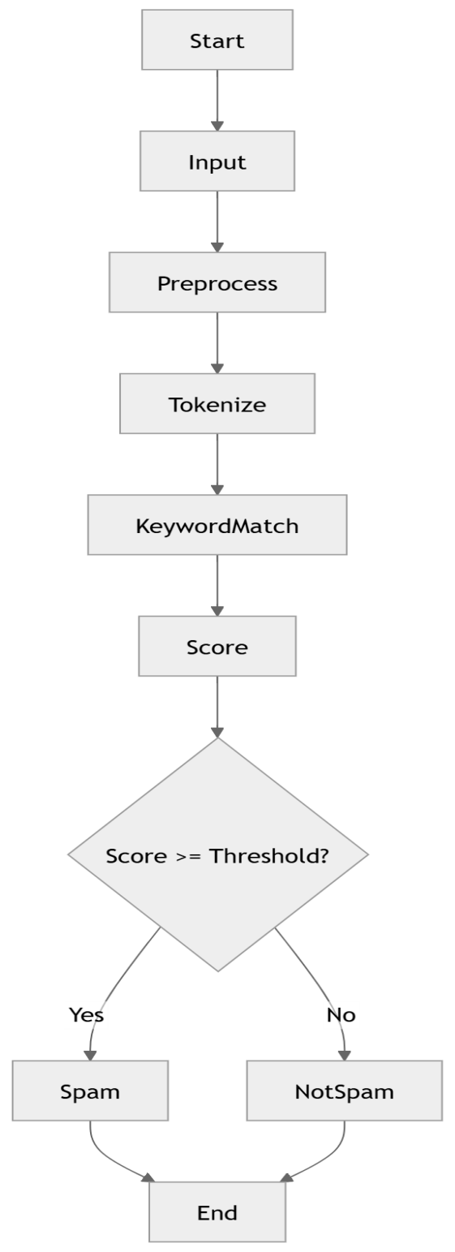

The activity diagram shows step-by-step execution of the system. Input is taken from the user, preprocessed, tokenized, and analyzed using keyword matching. A score is calculated and compared with a threshold to produce the final result.

3.1 High-Level Design
The system is divided into four major modules:

1. GUI Module
It is responsible for user interaction.

2. Text Preprocessing Module
It is responsible for cleaning raw input.

3. Spam Detection Module
It is responsible for analyzing text.

4. Classification Module
It is responsible for final decision making.

3.2 Low-Level Design

3.2.1 GUI Module Design

Purpose
Use to provide a simple interface for users to interact with the system.

Features
- Input text box for message entry
- “Detect Spam” button
- “Clear” button
- Output label for result

Working
- User enters message
- Clicks button
- Input is passed to backend
- Result is returned and displayed

GUI Behavior
- Instant response
- No page reload
- No external navigation

3.2.2 Text Preprocessing Module

Purpose
Use to convert raw human language into machine-readable format.

Steps Involved

Step 1: Lowercasing
It converts all text to lowercase to ensure uniformity.

Step 2: Removing Punctuation
Removes symbols like:
- !, ?, ., ,, @, #

Step 3: Tokenization
Splits sentence into words.

Step 4: Cleaning
This removes extra spaces and irrelevant characters.

Example
Input:
WIN FREE CASH NOW!!!
Output:
["win", "free", "cash", "now"]

3.2.3 Spam Detection Module

Purpose
To identify whether a message is spam using rule-based logic.

Core Mechanism
- Keyword matching system
- Pattern recognition using regex
- Weighted scoring system

Spam Keyword Categories

High Risk Words
- win
- free
- urgent

Medium Risk Words
- offer
- bonus

Low Risk Words
- click
- now

Scoring System
Each word adds a value to spam score:
- High risk → 3 points
- Medium risk → 2 points
- Low risk → 1 point

Regex Detection
Detects patterns like:
- “click here”
- “limited offer”
- URLs in text

3.2.4 Classification Module

Purpose
To decide final result based on spam score.

Logic
- If score ≥ threshold → SPAM
- Else → NOT SPAM

Threshold Example
Threshold = 5

Output Types
- SPAM (red label)
- NOT SPAM (green label)

SEQUENCE DIAGRAM
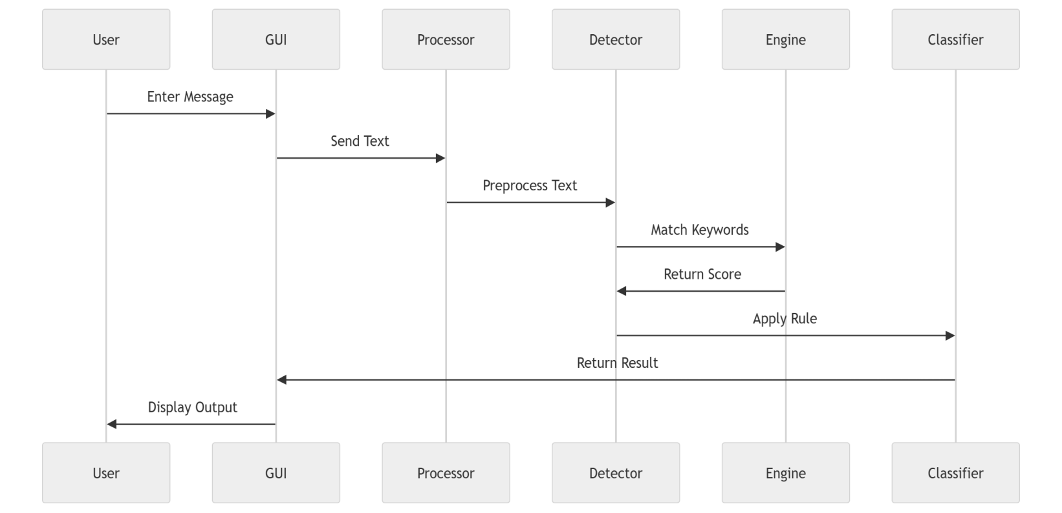
The sequence diagram represents communication between system components. Each module processes the data step by step until the final result is displayed to the user.

CLASS DESIGN
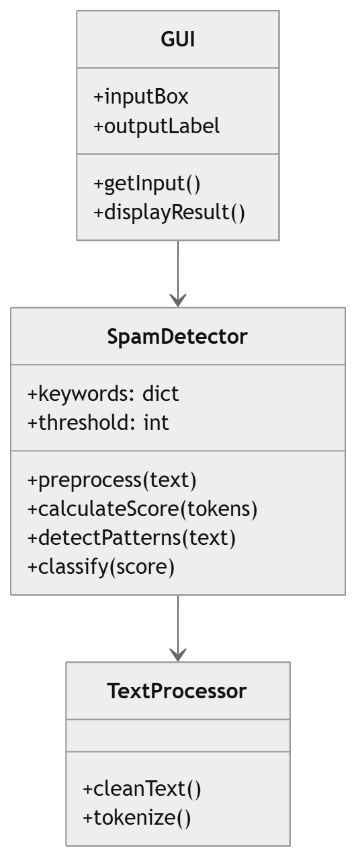
The system contains three main classes:
- SpamDetector: Core logic for spam detection
- GUI: Handles user interaction
- TextProcessor: Performs text cleaning and tokenization
These classes interact to ensure smooth processing from input to output.

Attributes
- Spam keywords → dictionary of words and weights
- threshold → decision limit

Methods

1. preprocess text(text)
It cleans input text.

2. calculate score(tokens)
Calculates spam score from tokens.

3. detect patterns(text)
This uses regex to detect spam patterns.

4. classify message(score)
It returns final result.

Object Interaction Flow
- GUI sends input
- Preprocess text() is called
- tokens generated
- calculate score() executed
- detect patterns() applied
- classify message() returns result
- GUI displays output

DATA FLOW DIAGRAM (DFD)
0 level:
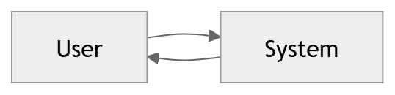

Level 1:
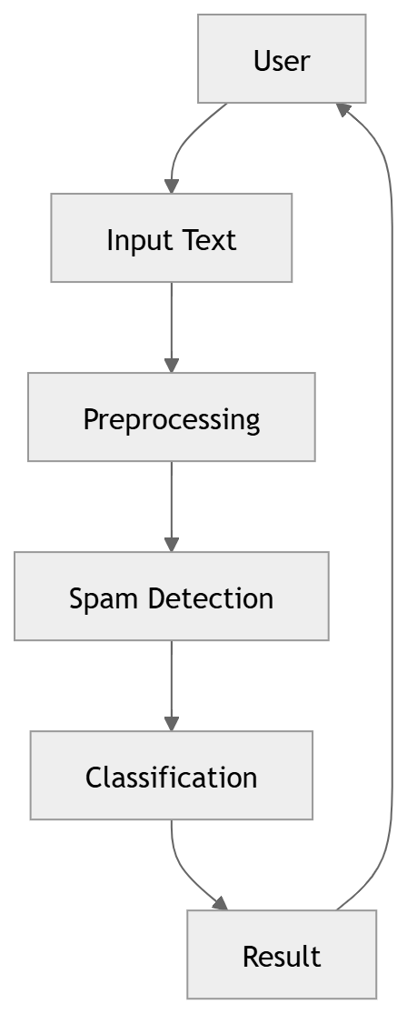
Data flows from user input to preprocessing, then to detection and classification modules. The final result is returned to the user

COMPONENT DIAGRAM
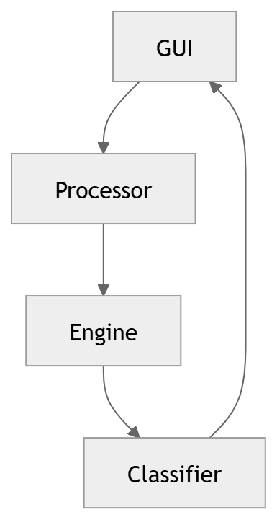

The system is divided into independent components. Each component communicates with others to ensure modular design and easy maintenance.

DEPLOYMENT DIAGRAM

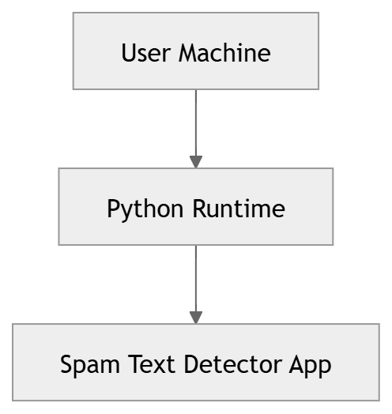

The system runs locally on a user machine using Python runtime. No external server or cloud dependency is required.

GUI DESIGN
--------------------------------------
| Spam Text Detector |
|-----------------------------------|
| Enter Message: |
| [ Text Input Box ] |
| |
| [ Detect Spam ] [ Clear ] |
| |
| Result: Spam / Not Spam |

The GUI is built using Tkinter. It includes a text input area, buttons for actions, and a result display section. The interface is simple and user-friendly.

5. SYSTEM WORKFLOW

Step-by-Step Process
- User enters message in GUI
- System receives input
- Text preprocessing begins
- Text is normalized
- Tokenization occurs
- Spam keywords are matched
- Score is calculated
- Regex patterns are checked
- Final score is compared with threshold
- System generates result
- Output is displayed in GUI

6. ALGORITHM DESIGN

6.1 Algorithm Explanation
The system uses a deterministic rule-based algorithm instead of machine learning.

6.2 Detailed Algorithm Steps
- Input message
- Normalize text
- Split into tokens
- Initialize score = 0
- For each token:
  - Check against spam list
  - Add weight if match found
- Apply regex checks
- Compare score with threshold
- Return classification

6.3 Strength of Algorithm
- Fast execution
- No training required
- Works offline
- Easy to modify

7. DATABASE DESIGN

7.1 Database Usage
No external database is used.

7.2 Internal Data Storage

Spam Keywords Dictionary
Stored in Python memory:
{
"free": 3
"win": 3
"urgent": 2
"offer": 2
"click": 1
}

7.3 Advantage
- Faster processing
- No database overhead
- Simple architecture

8. INTERFACE DESIGN

8.1 GUI Structure
- Title bar: Spam Text Detector
- Input area: Multi-line text box
- Button panel:
  - Detect Spam
  - Clear
- Output section: Result display

8.2 User Experience Flow
- Open application
- Enter message
- Click detect
- View result instantly
- Clear input for next message

9. TECHNOLOGY DESIGN

Core Technologies

Python
- Core logic implementation
- Backend processing

Tkinter
- GUI development
- Event handling

Regex (re module)
- Pattern detection
- URL detection

String module
- Text cleaning
- Formatting

Rule-Based NLP
- Keyword detection
- Score-based classification

10. PERFORMANCE DESIGN

Features
- Real-time response (<1 second)
- Low memory consumption
- No background processing
- No external dependencies

Optimization
- Preloaded keyword list
- Simple string operations
- Minimal loops

11. SECURITY DESIGN
- No user data stored
- No internet access required
- No external API calls
- No database risks
- Fully offline system

12. LIMITATIONS
- Cannot detect advanced spam patterns
- Depends heavily on keyword list
- No learning capability
- Limited accuracy compared to ML systems
- English-only support

13. FUTURE ENHANCEMENTS

Possible Improvements:
- Machine Learning Integration
  - Naive Bayes
  - SVM classifier
- Large Dataset Support
- Email integration
- Mobile application version
- Cloud-based spam detection
- Multi-language support
- Real-time messaging app plugin

14. CONCLUSION
The Spam Text Detector is a lightweight, efficient, and practical desktop application built using Python and Tkinter. It demonstrates how rule-based Natural Language Processing techniques can be used to solve real-world problems like spam detection without requiring complex machine learning models.
The system is:
- Fast
- Simple
- Easy to maintain
- Suitable for educational use
It provides a strong foundation for understanding text classification and can be extended in the future into a more advanced AI-based system.

